Chapter 17, Solution 35.

If v_{s} in the circuit of Fig. 17.72 is the same as function f₂(t) in Fig. 17.57(b), determine the dc component and the first three nonzero harmonics of v_{o}(t).

v_{S}

+
−
1 Ω
1 Ω
1 H
+
v_{o}
−
1 F

Figure 16.64 For Prob. 16.25

t
5
4
3
2
1
0
-1
-2
2
f₂(t)
1

Figure 16.50(b) For Prob. 16.25

The signal is even, hence, b_{n} = 0. In addition, T = 3, ω_{o} = 2π/3.

v_{s}(t) = 1 for all 0 < t < 1
= 2 for all 1 < t < 1.5

a_{o} = 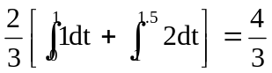

a_{n} = 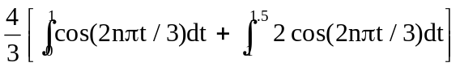

= 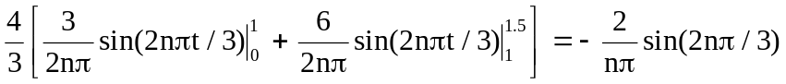
v_{s}(t) = 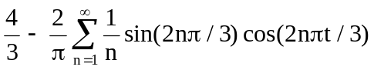

Now consider this circuit,
v_{S}

+
−
1 Ω
1 Ω
j2nπ/3
+
v_{o}
−
-j3/(2nπ)

Let Z = [-j3/(2nπ)](1)/(1 – j3/(2nπ)) = -j3/(2nπ - j3)

Therefore, v_{o} = Zv_{s}/(Z + 1 + j2nπ/3). Simplifying, we get

v_{o} = 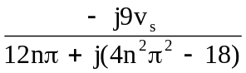

For the dc case, n = 0 and v_{s} = ¾ V and v_{o} = v_{s}/2 = 3/8 V.

We can now solve for v_{o}(t)

v_{o}(t) = 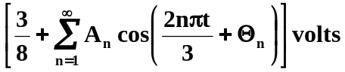

where 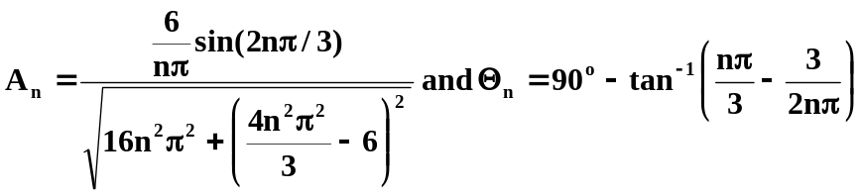

where we can further simplify A_{n} to this, 